***Prescription Planner Module***

***Objective:***

***The core objective of this module is to “create timely medication reminders that remind patients about the meals that they need to take everyday, based on the prescriptions that they have” while providing control over the meal times, days to take the medicine, and customized reminders as per the patient’s choice. So now let me go through rough workflow of how this prescription planner module structured.***

***Workflow:***

***1) First of all, while entering to this module, the patient is requested to upload their new prescription or existing prescriptions that they have to provide a medication reminders for their prescription.***

***2) After the prescription being uploaded from the patient side, we process the image and render a template to the patient by extracting the medication details present in the prescription as a prescription plan.***

***3) In this phase the patient are allowed to edit the prescription plan that the AI made for them, by changing the medicine name, intake type, reminder types and so on.***

***4) Once the patient done with the changes and confirm the prescription plan, the AI requests the patient for their meal time according to the prescription that they have uploaded.***

***5) After collecting the meal time from the patient, the AI again renders a new templete which is similar to the previous template but with meal time details along with the medication details. And patients are allowed to change the meal timings as per their need.***

***6) Once the patient is okay with the meal timings, the AI sets the reminders for the patients the calling the relavant tools. And this is the end of our Prescription Planner workflow.***

***7) Additionally we can see our most recent medication plan after setting the reminders in both chat window and my activity page.***

***Tables Involved:***

***The tables involved in our Prescription Planner module is mentioned below and a overall description about the table in our Module.***

***1) PatientPrescription***

***2) PrescriptionPlanner***

***3) Reminder***

***PatientPrescription Table:***

***This table is responsible for storing each patient’s prescription along with the prescription Image, Plain Text of the Image, Extracted JSON from the Image, And the Uploaded date.***

***PrescriptionPlanner Table:***

***This table contains the plan details for each prescription of the patient, where each row contains the details of each medicine inside the prescription along with dosage, start date, end date of the medicine inside the plan, intake type of the medication and also contains the reminder times for the medication. It is the main table that acts as the origin for our prescription plan and the source for our reminder table.***

***Reminder Table:***

***This table mainly contains the reminder details of the each medicine in the current medication plan including the grouped medications for the specific time and date and mode (AF/BF). Along with the message of the reminder relevant to the mode and reminder type(pre, post, current). And it also have column to capture the user response to each reminder message.***

***With these being the functionalities of the Tables that are involved in our Medication Reminder Module.***

***Prompts & Tools:***

***As each module has their own prompts and tools to build their agents, this module is also comprises of them. You can find the prompt for this module, by navigating into the project’s “prescription_planner” directory and “prompt.py” module and a variable called “prescription_prompt”.***

***Tools:***

***For this module, we have around 8 tools which are meant for unique functionalities that is essential for our module to function properly and ensure proper reminder scheduling. Here I will give a overall view about what each tool is meant for. For better understanding, I will walk through with the order of each tool being called in our workflow.***

***Tools based on the workflows:***

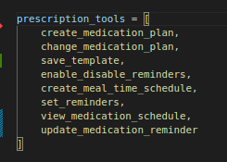

***As you can see in the above figure, these are the tools which are ordered in a way that aligned with the flow of our normal workflow.***

***Tool 1: create_medication_plan***

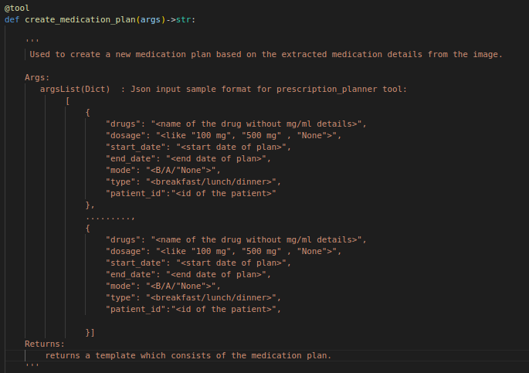

***This the description of our first ever tool to be called inside the prescription planner module. And from the above description you will know that this tool is being called right after the patient uploaded their prescription.***

***When the patient intially uploads an image, we put an entry in our “patientprescription” table with the image details including extracted text, extracted json, thread id of the conversation and patient id of the prescription and attach the Prescription’s details with our prompt.***

***So when the Agent receives the prompt (with prescription details) with user input, It initially calls this tool “create_medication_plan” to extract the json from the given prompt and save the extracted json to the table (patient prescription) and return a json structure to the frontend to show the medication plan.***

***Tool 2: change_medication_plan***

***After the patient views their medication plan which is the output of the “create_medication_plan”, the patient can change their medication plan like add / delete / edit a medicine, edit the dosage details of medicine, edit the start time and end time of a medicine. And for changing the medication plan we use the below tool, which collects the modification that patient requests and do the changes the medication json of the patientprescription and save them inside the table and returns the modified prescripton json to the UI to re render the template to user.***

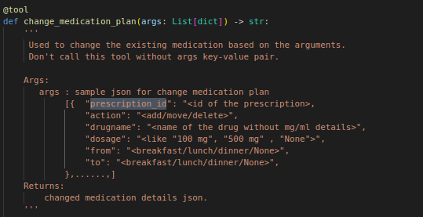

***Tool 3: save_template***

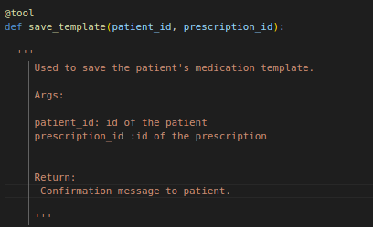

***This tool is responsible for saving & confirming the medication plan once the patient done with the changes. After the patient is done with the changes in the medication plan, they provide confirmation for the plan, when the patient provides confirmation to the plan the above tool is called and migrates the data from PatientPrescription table to PrescriptionPlanner table and return a response to the UI which collects the meal time details from the patient.***

***Tool 4: create_meal_time_schedule***

***This tool is called once the patient selects the meal time for the medication plan and confirms the same. So after patient confirms the meal time it update the reminder time details in PrescriptionPlanner table and update the json if any changes and return the json to the UI to re render the medication plan template along with meal time details.***

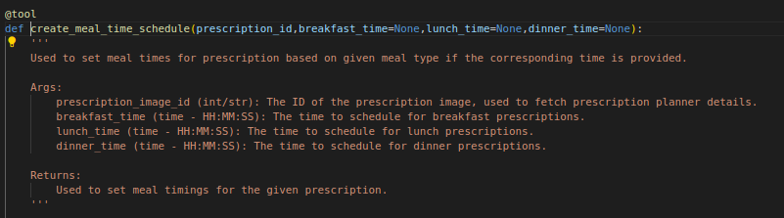

***Tool 5: enable_disable_reminders***

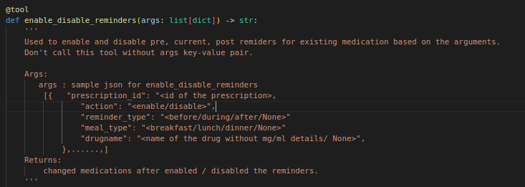

***This tool is responsible for enabling / disabling the reminders of the created medication plan for the prescription. This will be only called if the user wants to enable / disable their reminders of their plan and not meant to be called every time inside our workflow.***

***Tool 6: set_reminders***

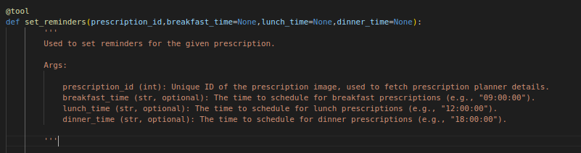

***Once the patient is okay with their medication schedule, they provide confirmation to the schedule by giving their confirmation. This tool is being called to set reminders to create the actual reminders by migrating the data from PrescriptionPlanner table to Reminders Table. And after this one tool our main workflow is completed.***

***Tool 7: view_medication_schedule***

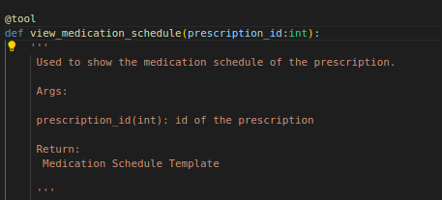

***This tool is used to view the complete schedule of the patient’s recent prescription along with the reminder time for each medication. And this can be called in both chat and my activity pages.***

***Tool 8: update_medication_reminder***

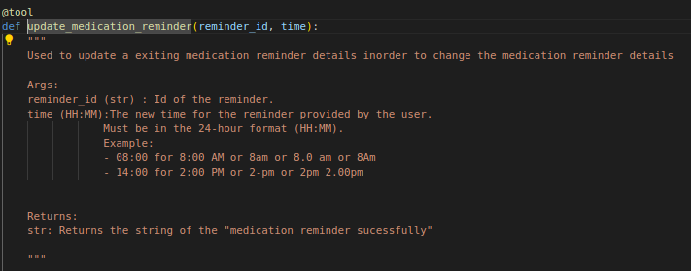

***This tool is being called by the LLM when the patient wants to update the reminder time of a specific reminder and it receives the reminder id and new time as input and did changes inside the table of Reminder.***

***Apart from this, we use 2 APIs externally inside our workflow which will be explained below.***

***APIs:***

***1) updateMedicationPlan/***

***2) updateReminderResponse/***

***API 1: updateMedicationPlan***

***This API is being called implicitly, Whenever the user updates the medication plan whether during initial plan modification or modifications during meal time changes or changes occurs inside my activity panel. This API receives the JSON of template data after the patient done with their changes, and make changes to the database according to the changes.***

***API 2: updateReminderResponse***

***This API is used to update the reminder response details of each reminders based on the user response provided it controls the flow of how the supporting reminders are gonna triggered or not.***

***Prescription Planner Workflow with UI:***

***In this part, we will walk through on how the Prescription Planner Works in real time using our application. To picturize the same, I have taken some screenshots of the flow steps and explain them in below.***

***1) As the patient enters our prescription planner module by tapping on the prescription planner category, after this the patient is navigated to the chat page with a welcome message along with a prompt to upload the prescription.***

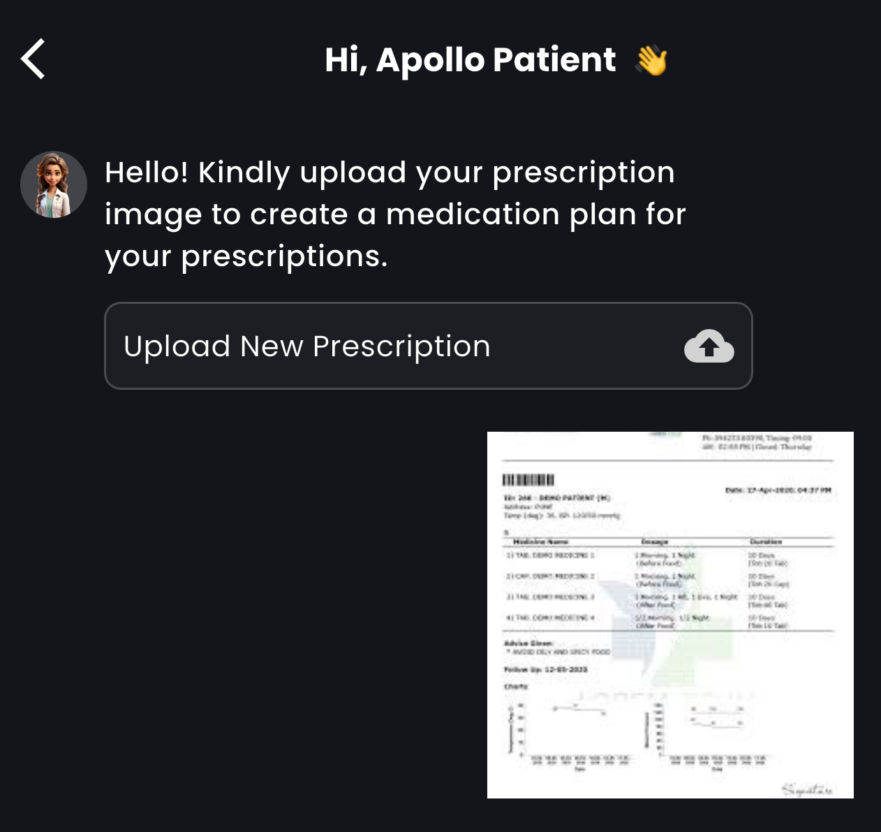

***2) After seeing the AI’s initial message, the patient usually uploads their prescription to begin with the prescription plan. As seen in the above message.***

***3) So right after the patient uploaded their prescription, the AI reads the content of the prescription and checks whether the prescription has number of days for it. If it has the number of days, it directly calls the “create_medication_plan” tool to create a medication plan by extracting the medication details and return the same to UI to render them as a Template. Else the AI prompts the patient back to provide the number of days which is used to determine how much days they want a reminder to the plan which will be shown in the below image.***

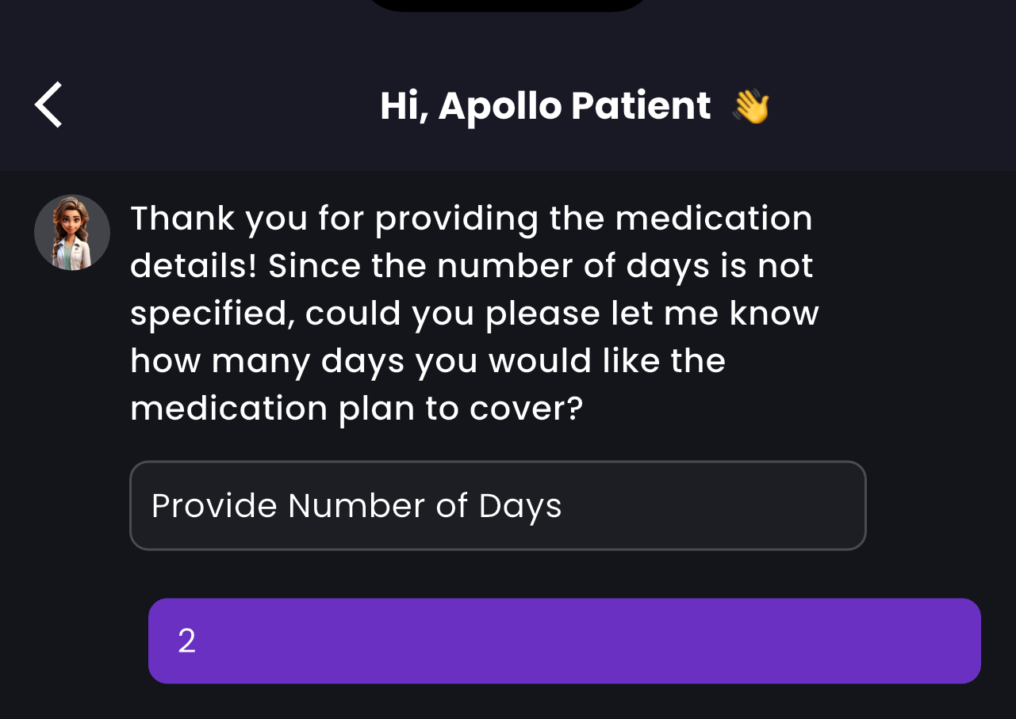

***4) So after the patient provides the number of days for their medication, the AI calls the “create_medication_plan” tool to create the medication plan out of the given prescription and return it to UI for rendering as template which is seen in the below image.***

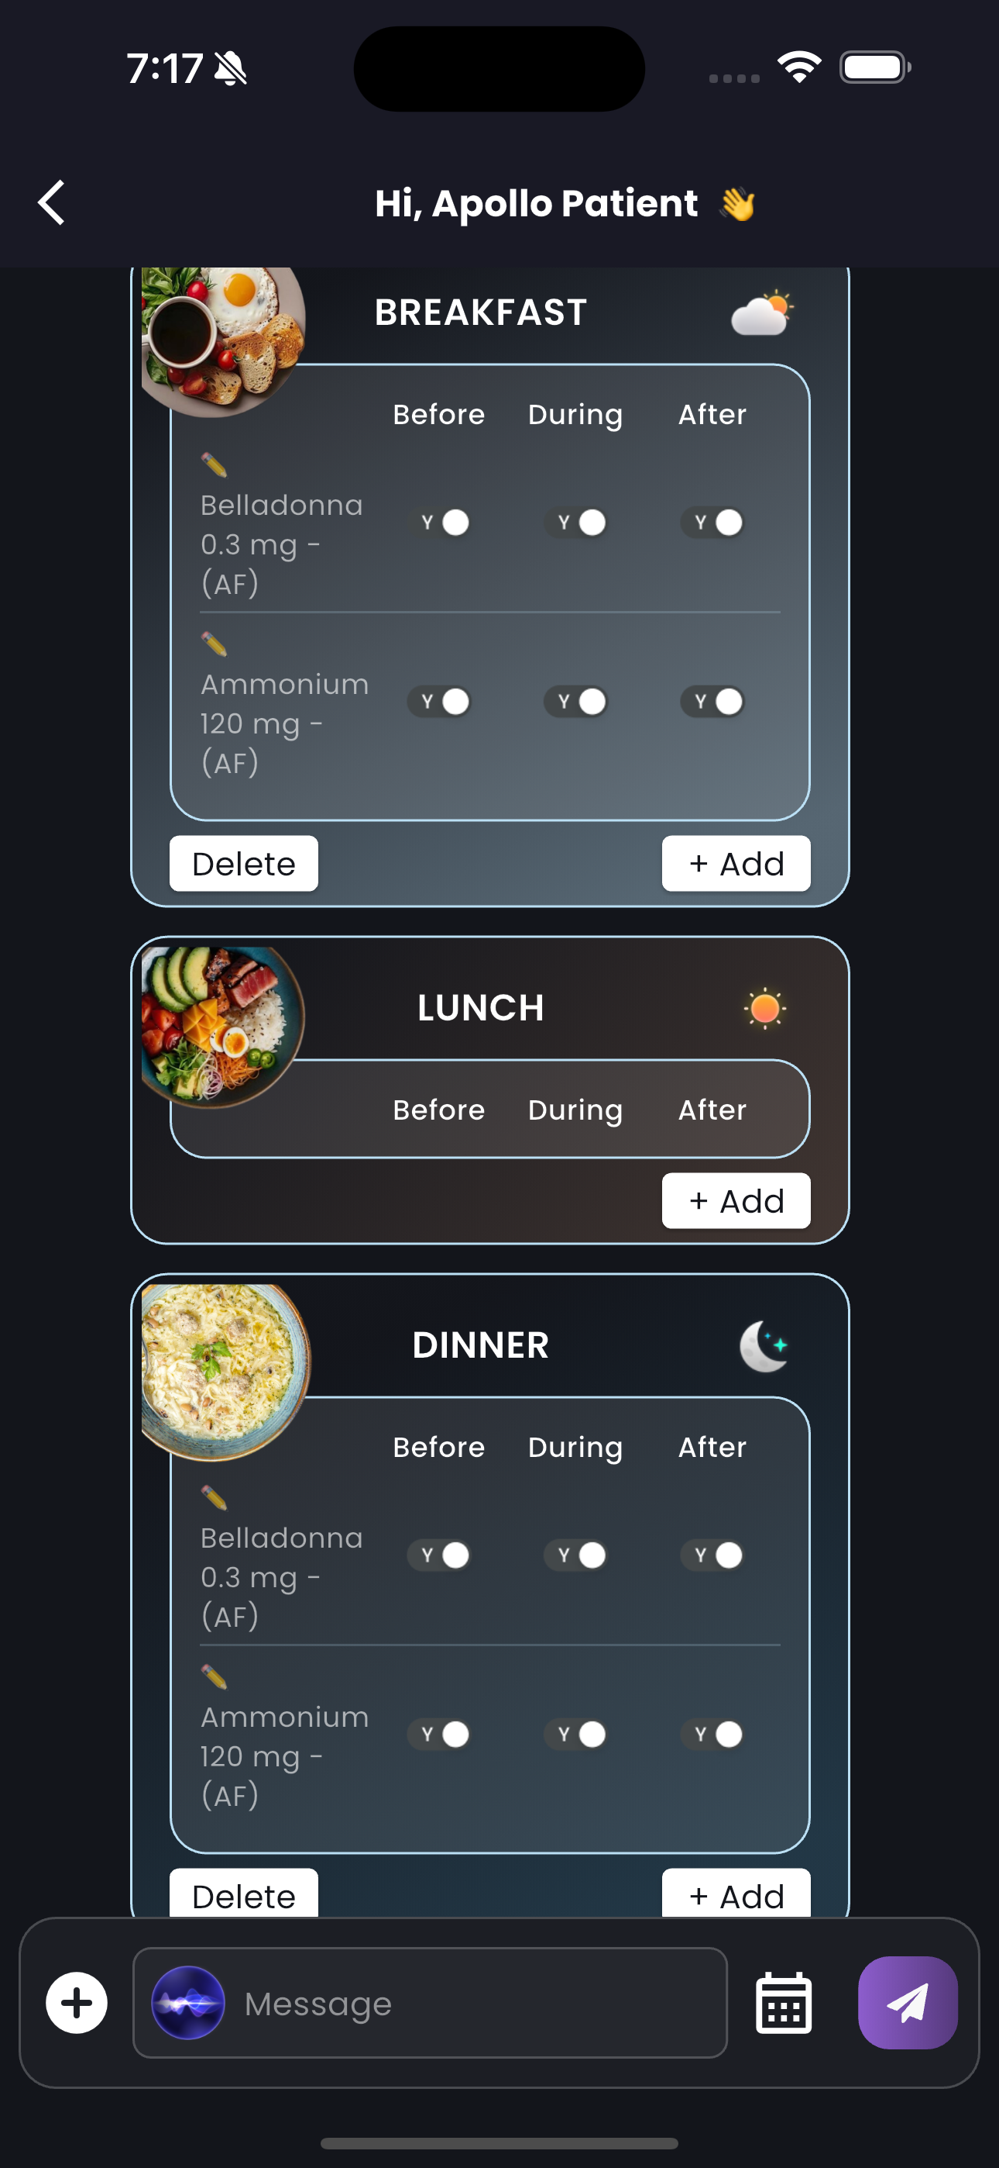

***As you can see in the above message this is the template that is being created in UI from the medication data passed from the “create_medication_plan” tool. And you can add, edit, delete a medication, or enable / disable their reminders according to thier need. This alterations can be done in the UI template or by typing your changes inside the chat box. And to handle this changes in medication and enabling & disabling reminders, the AI utlilizes two tools namely “change_medication_plan”, “enable_disable_reminders” as we discussed in previous sections.***

***5) After the patient done with the changes and proceeded to confirming the plan, the AI calls a tool named “save_template” which freezes the current medication plan by migrating the plan data from PatientPrescription table to PrescriptionPlanner table and return a response that prompt the patient to provide a meal timings for their medicines to perfectly set the reminders for the same. You will see the response came from the “save_template” tool below.***

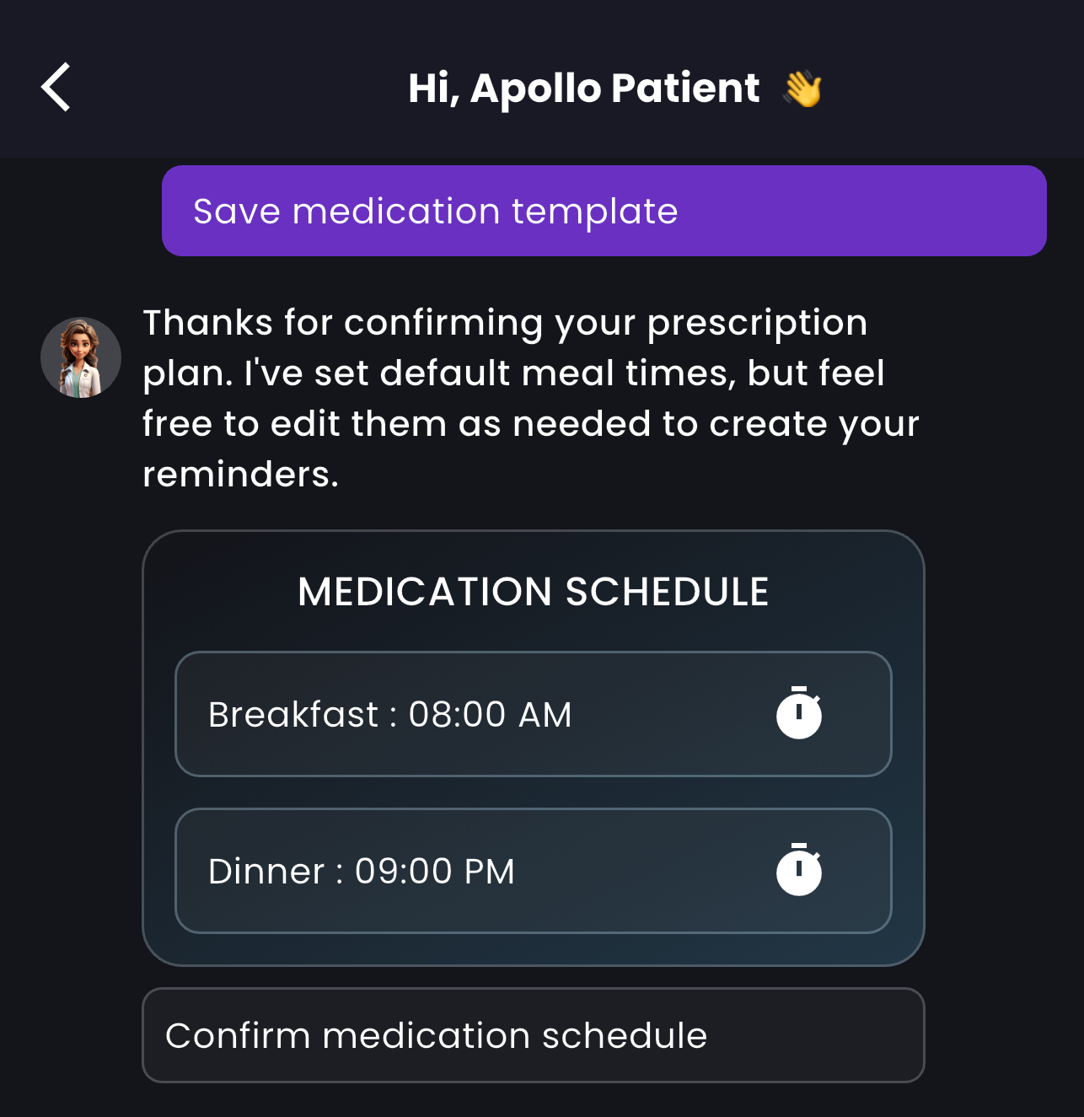

***As you can see here, the tool only collects the breakfast and dinner time from the user not lunch time, as because the prescription doesn’t have any medications during their lunch time. Here we provided some default times for their meal time, However if the patient want to change the meal time they can do the same by clicking on the clock icon and set their convenient times. The clock image will looks something like the below.***

***The clock will be opened as a popup to collect the time data and set the same with relevant meal times.***

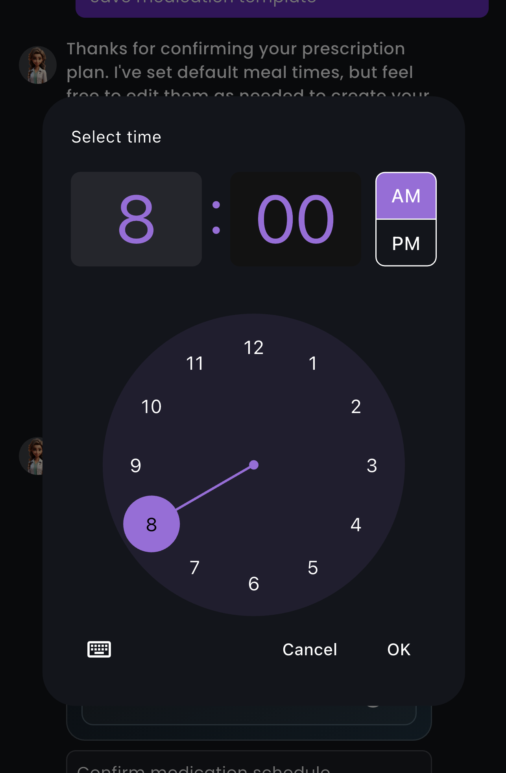

***6) After the patient chooses their meal time and gave confirmation to the medication schedule, the AI will call a tool named “create_meal_time_schedule” which not only updates the meal tims of the plan and also generates the reminder times for each medicine in the current plan and returns the medication details along with the reminder times which will be used to render a Template to the Patients most likely the one we have seen before but with reminder times also.***

***As the template’s image given below, likewise in the first template here also you are allowed to edit the medication details aswell as the reminder times and also able to enable and disable specific reminders either through template or using chatbox messages.***

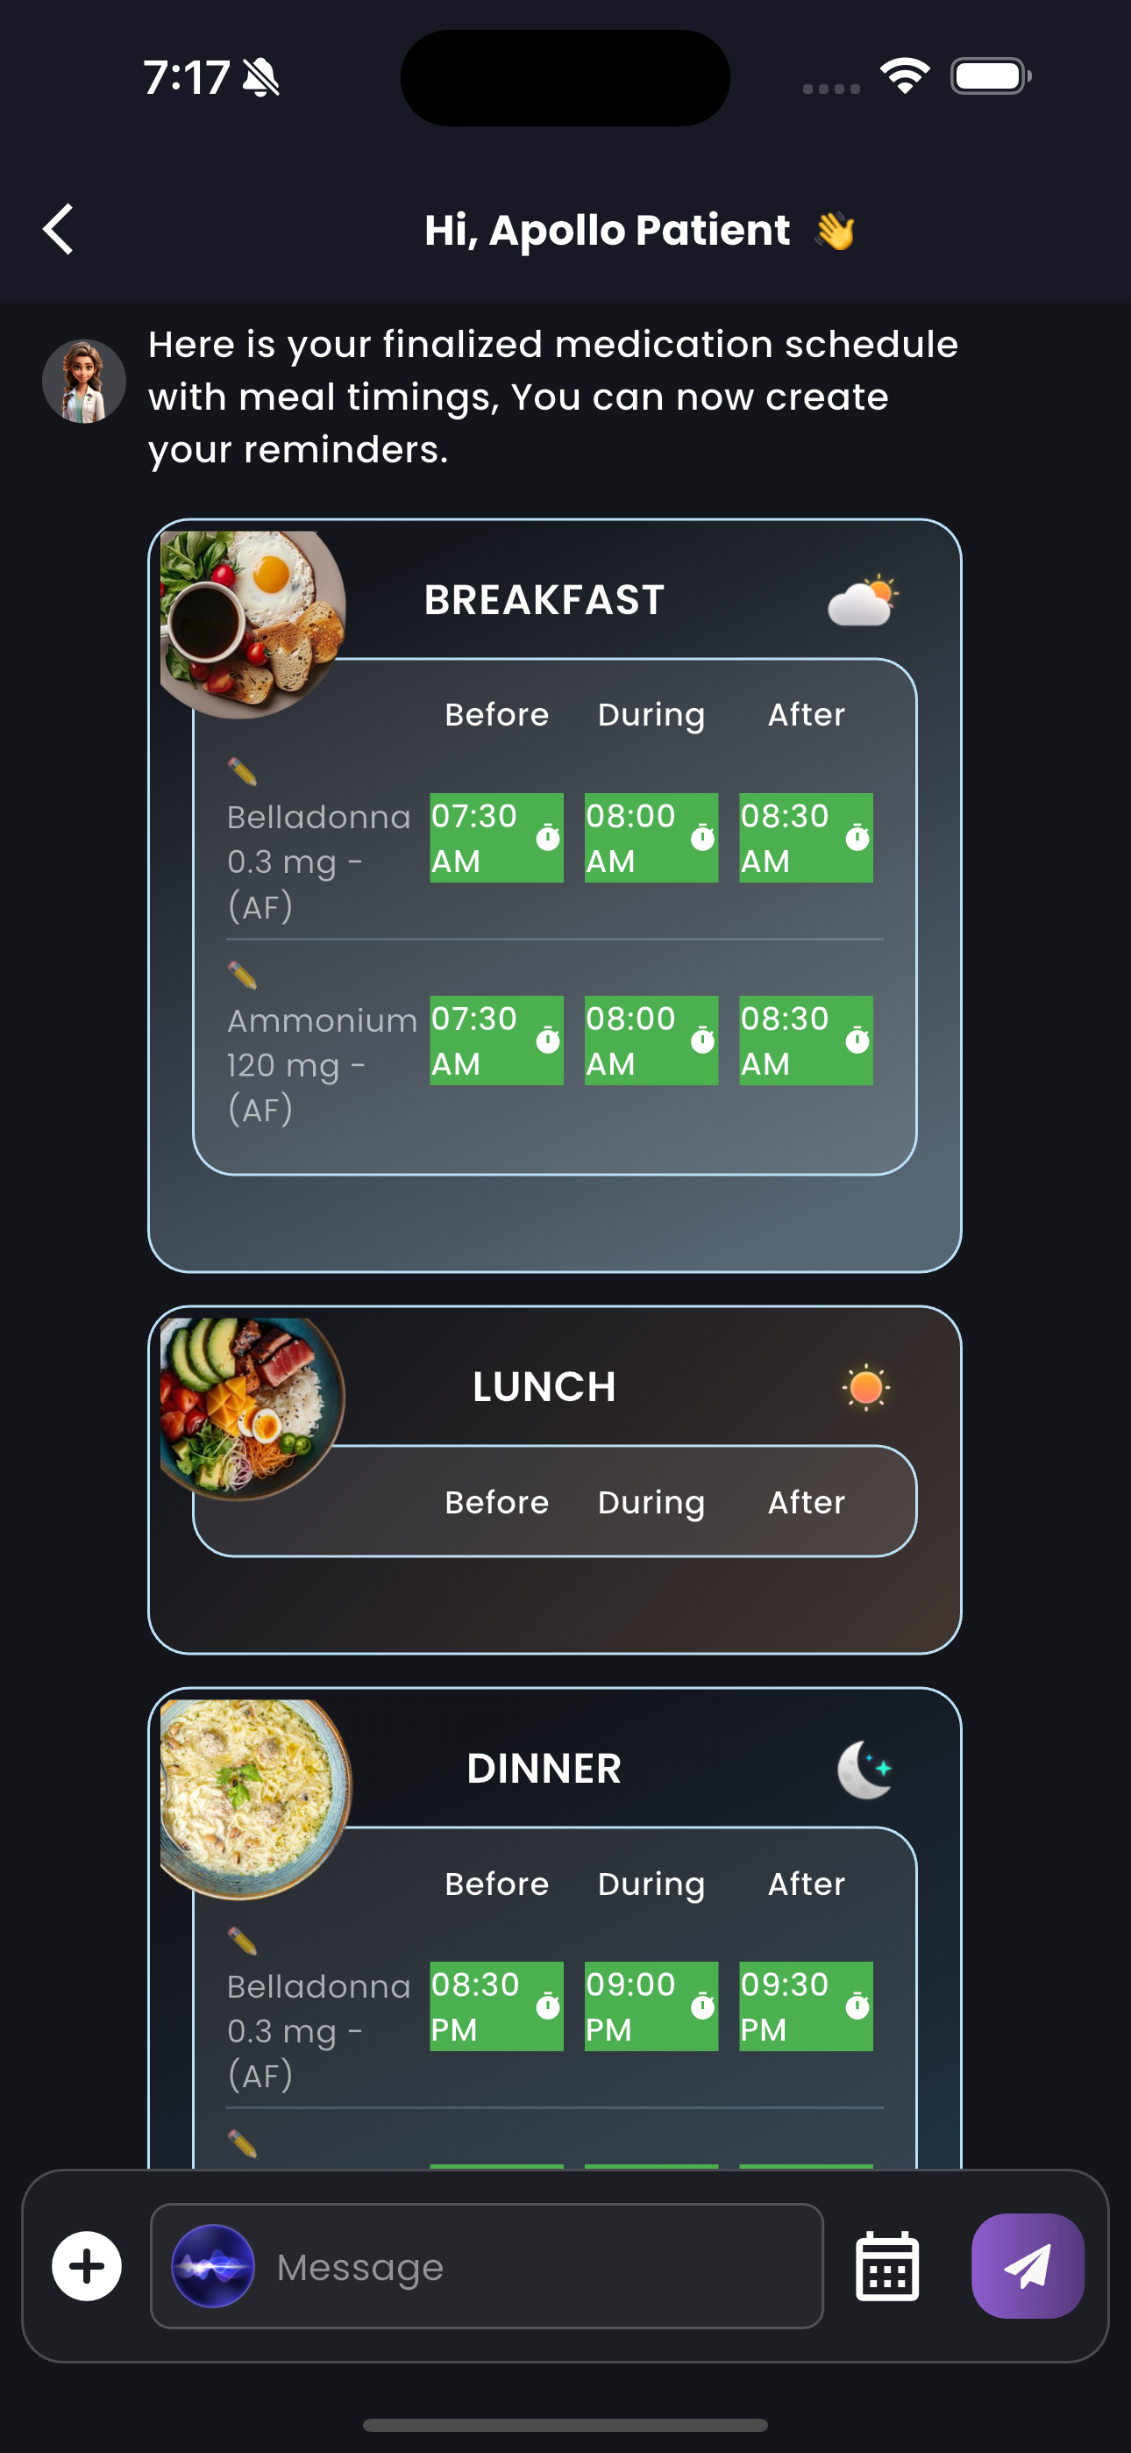

***7) After this stage when the patient is done with their changes and and want to move further, the thing they need to do is just clicking the set reminder button as this is the final step that we encounter in our prescription planner flow.***

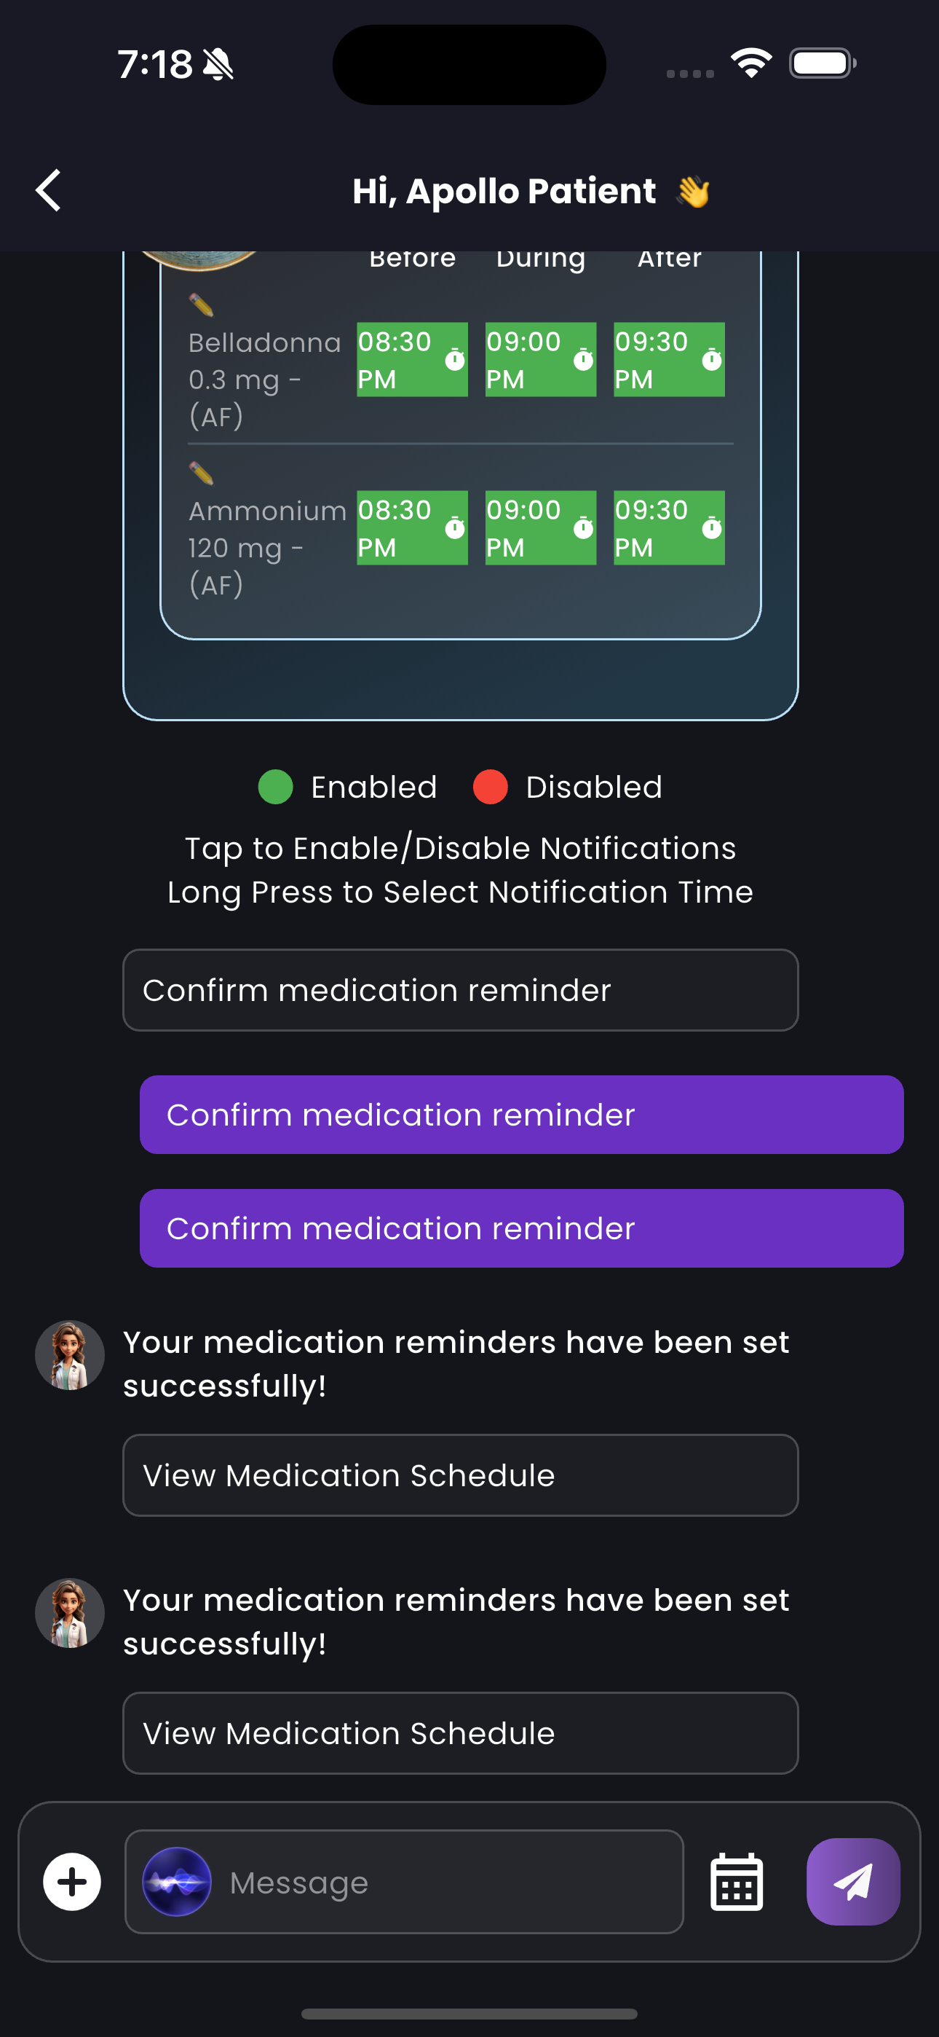

***So after this step our core prescription planner flow will come to the conlusion. There after we have only to functionalities one is update the reminder times if the patient requested by replying to the notification messages. Or else they can change their plan in their my acticity page’s reminder tab which consists of the most recent prescription plan of the patient. I will also give a image for the same below.***

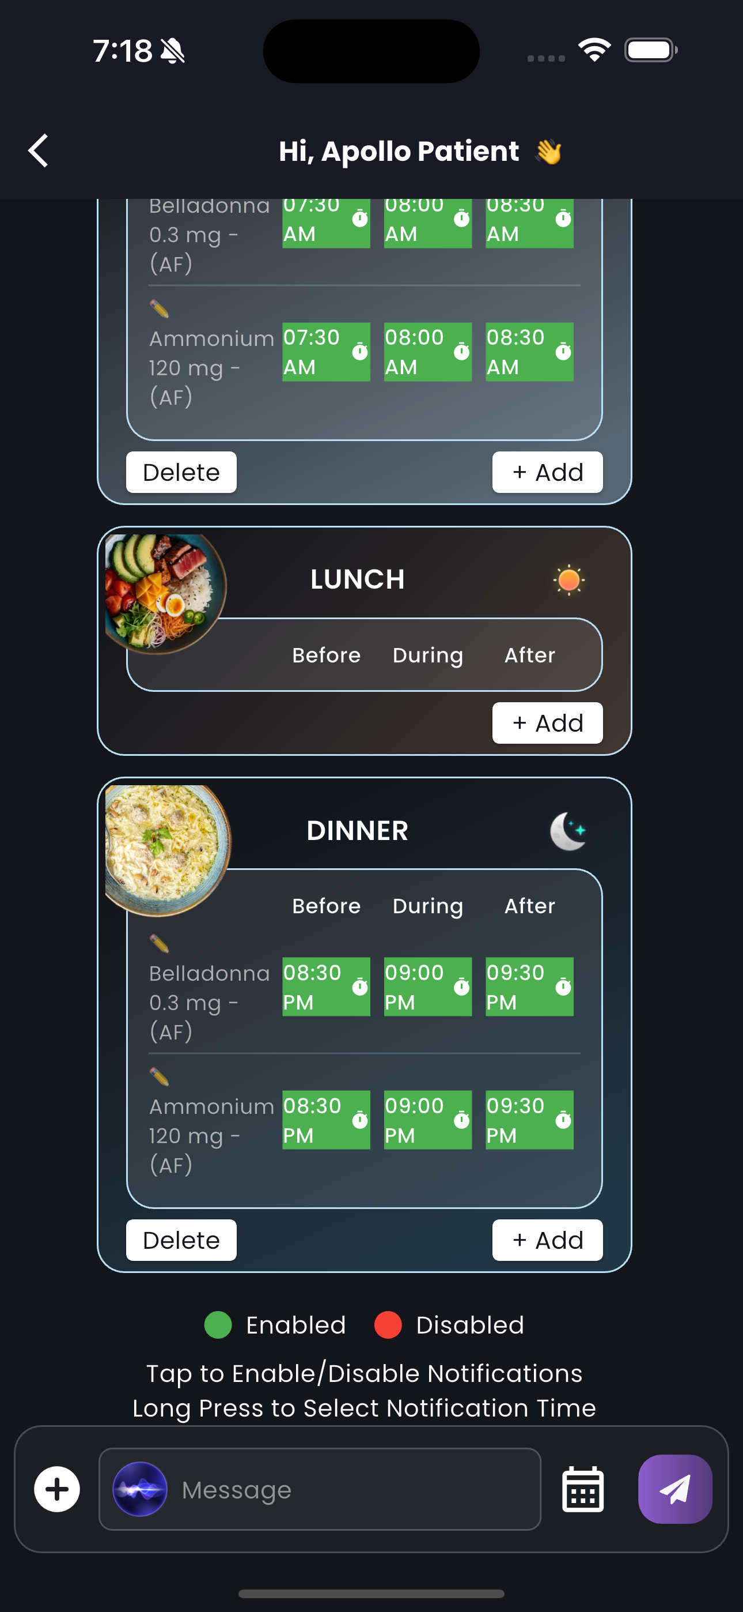***Although It may look like the 2nd template of ours. This is also the template that we show in our my activity tab for allowing the patient to edit their plan accordingly. That’s it....***